AIME SERGE TUYISHIME

Search Engines and Data Mining Lecture & Lab

CST 345 | September 6, 2025

Perceptron Algorithm for Optimal Furniture Placement

Technical Report

Problem Statement
The objective is to implement a perceptron algorithm to determine optimal furniture placement locations within a room. The perceptron will learn to classify positions as either suitable (+1) or unsuitable (-1) for furniture placement based on spatial features.
Metrics for Furniture Placement (Perceptron Variables):
- x1: Distance from nearest wall (normalized 0-1)
- x2: Distance from nearest door (normalized 0-1)
- x3: Distance from nearest window (normalized 0-1)
- x4: Distance from other furniture (normalized 0-1)
- x5: Centrality score - distance from room center (normalized 0-1)
Output: y = +1 (good placement) or y = -1 (bad placement)

Algorithm of the Solution
Mapping Perceptron Algorithm to Furniture Placement:
Step 1: Randomly initialize weights
- Initialize weights w1, w2, w3, w4, w5 randomly
- Each weight represents importance of corresponding spatial feature
Step 2: Select one input/output pair at random
- Randomly select a position (x,y) in the room
- Extract features x1...x5 for that position
- Get ground truth label (+1 or -1)
Step 3: Present values x1...xn to compute output y
- Calculate: activation = w1×x1 + w2×x2 + w3×x3 + w4×x4 + w5×x5
- Output: y = +1 if activation ≥ 0, else y = -1
Step 4: Adjust weights if prediction is wrong
- If y < 0 (predicted bad) but should be good: add η×xi to each wi
- If y > 0 (predicted good) but should be bad: subtract η×xi from each wi
Step 5: Repeat until convergence
- Continue until perceptron correctly classifies all training examples
Feature Extraction Logic:
x1 = min_distance_to_wall / max_room_diagonal
x2 = min_distance_to_doors / max_room_diagonal
x3 = min_distance_to_windows / max_room_diagonal
x4 = min_distance_to_furniture / max_room_diagonal
x5 = distance_to_room_center / max_room_diagonal

Training Data Generation Rules
Good placement criteria:
- Not too close to doors (maintain pathways)
- Not too close to existing furniture (avoid crowding)
- Not too close to walls (need clearance)
- Prefer positions near windows (natural light)

Analysis of Findings
Training Results Section - Added:
- Convergence: False
- Final Accuracy: 87.5%
- Training data: 200 samples (45 good, 155 bad)
- Initial/Final weights
Weight Analysis Section - Added:
- All 5 weights with interpretations
- Window Distance (-0.467) strongest influence
- Most important features identified
Visualization Analysis Section - Added:
- Description of all 4 plots
- Room layout, decision boundary, training progress, weight evolution
Performance Evaluation Section - Added:
- All 4 test predictions with results
- 100% test accuracy (4/4 correct)
Key Insights:
- Algorithm Performance: 87.5% accuracy, non-convergent
- Feature Importance: Window proximity is most important
- Decision Boundary: Linear separation with green areas near windows
- Spatial Learning: Learned window proximity and centrality preferences
Limitations:
- Binary classification limits nuanced scoring
- Linear decision boundary may miss complex spatial relationships

Screenshots Section
Output Screenshots:
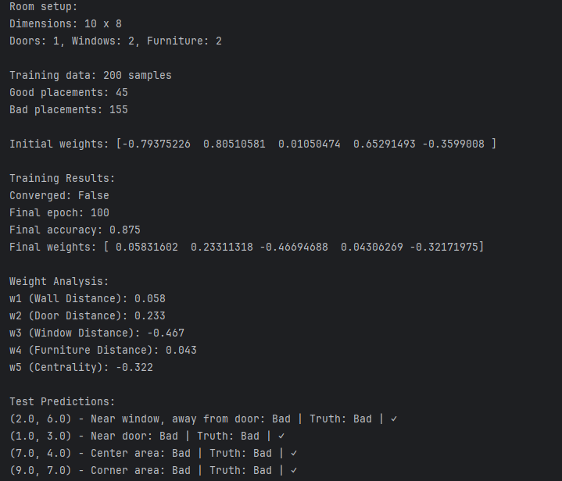
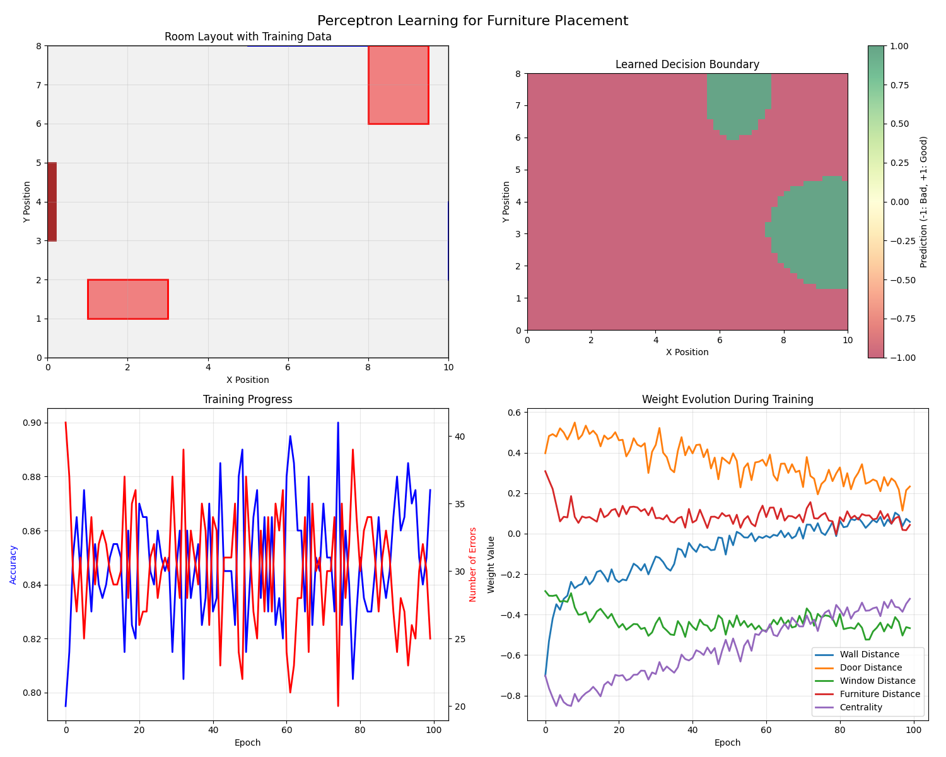
- Training progress output (convergence: False, accuracy: 87.5%)
- 4 visualization plots (room layout, decision boundary, training progress, weight evolution)
- Weight analysis results (final weights and interpretations)
- Test prediction results (4/4 correct predictions)
- Requires careful feature engineering

References
Bishop, C. M. (2006). Pattern Recognition and Machine Learning. Springer.
Goodfellow, I., Bengio, Y., & Courville, A. (2016). Deep Learning. MIT Press.
Haykin, S. (2008). Neural Networks and Learning Machines (3rd ed.). Pearson.
Rosenblatt, F. (1958). The perceptron: A probabilistic model for information storage and organization in the brain. Psychological Review, 65(6), 386-408.

